1. **INDEPENDENT SCALAR SUBQUERY**

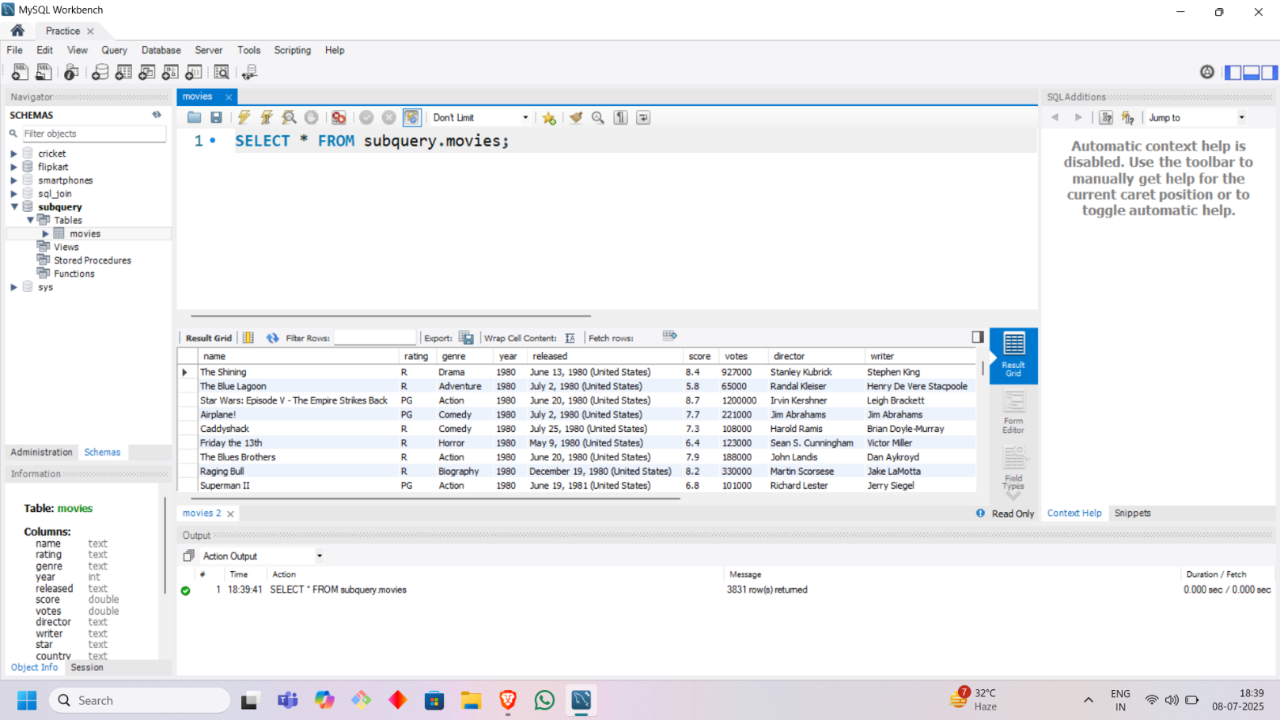

* **Find the movie with the highest profit**

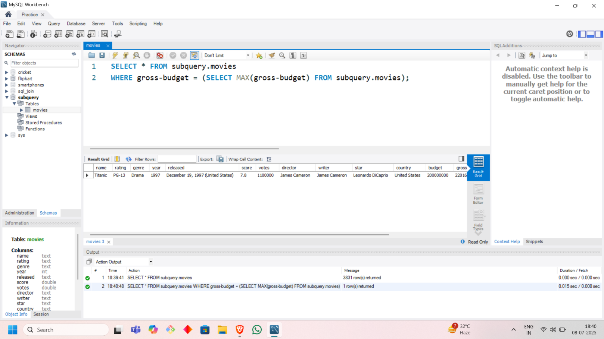

* **Find how many movies have a rating greater than the average of all the movie ratings**

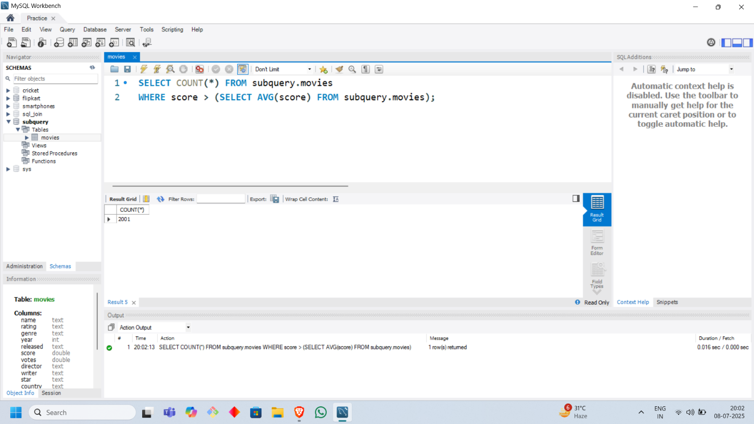

* **Find the highest rated movie of 2000**

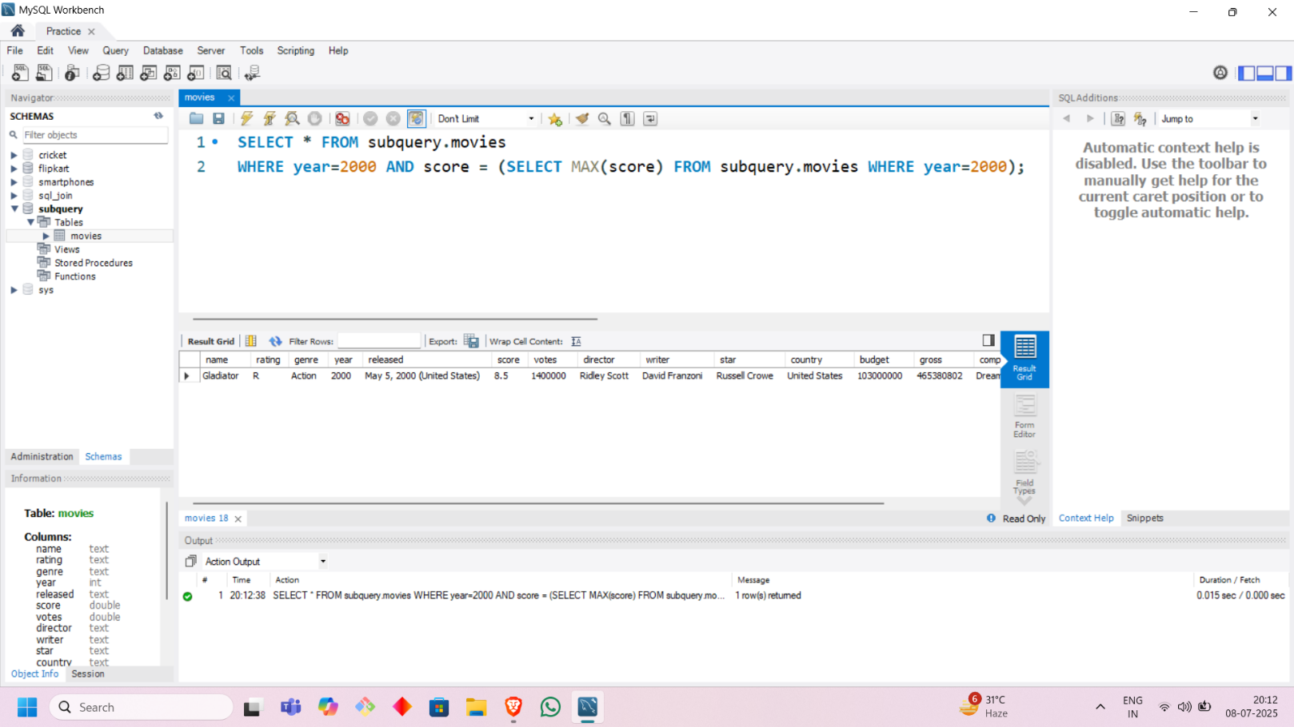

* **Find the highest rated movie among all movies whose number of votes are greater than average number of votes of all movies**

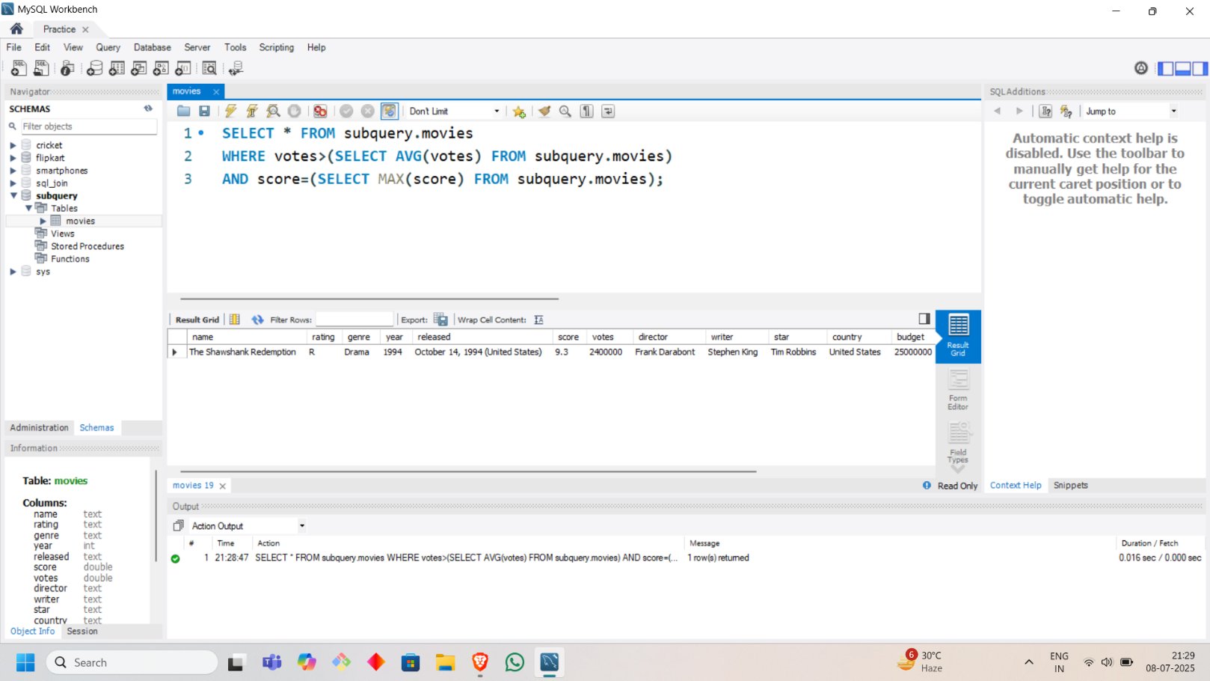

1. **INDEPENDENT ROW SUBQUERY**

* **Find all users who never ordered**

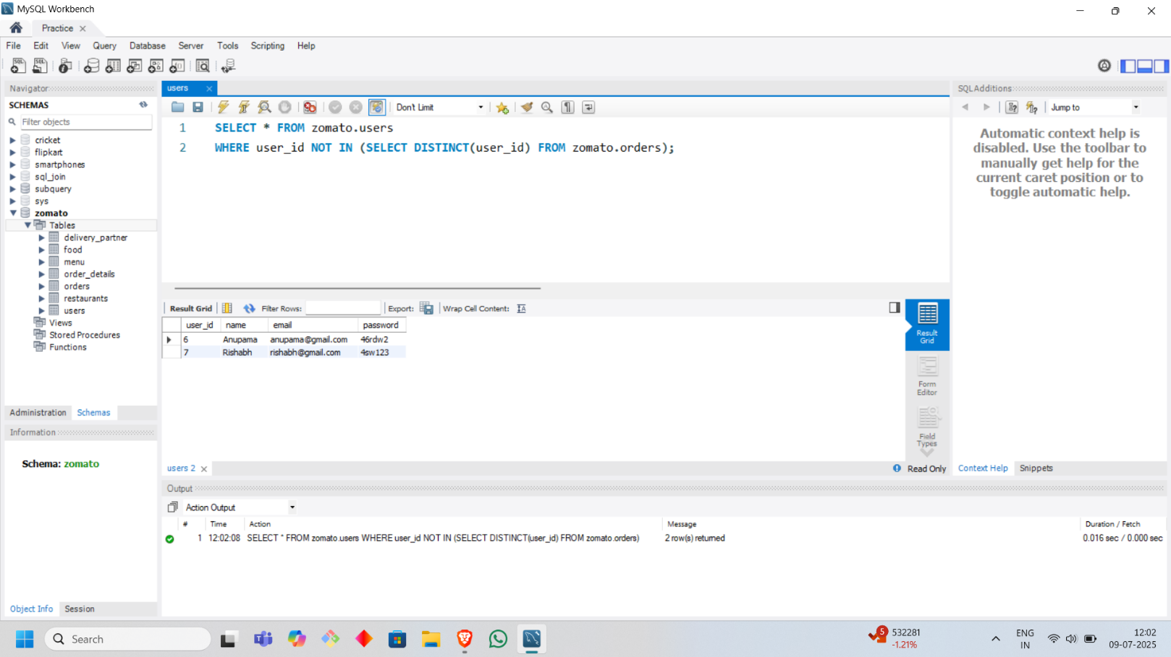

* **Find all the movies made by top 3 directors in term of total gross income**

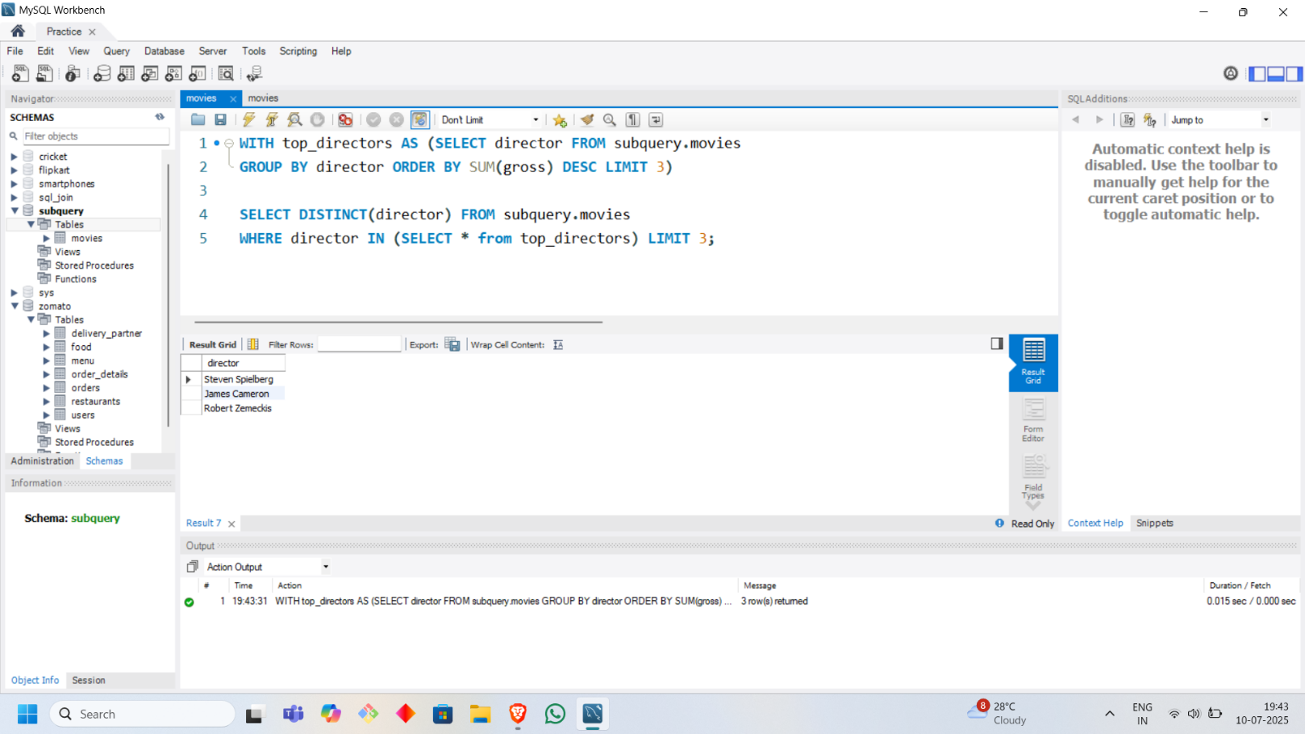

1. **INDEPENDENT TABLE SUBQUERY**

* **Find the most profitable movie of each year**

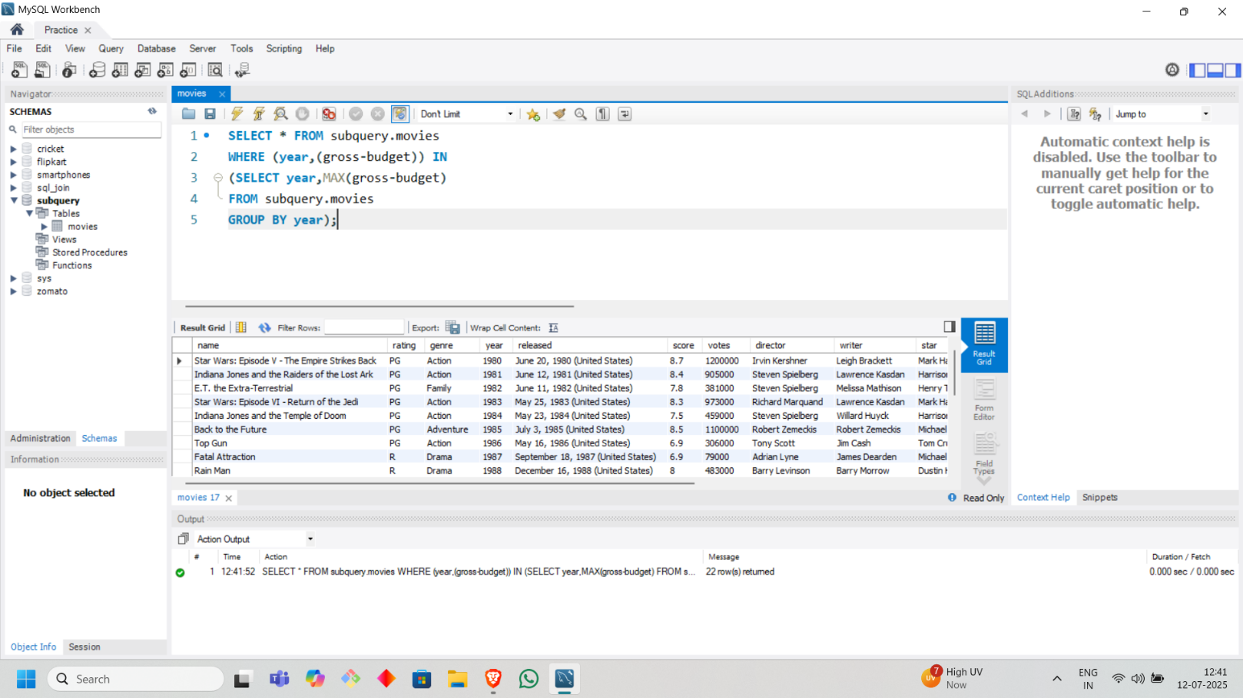

* **Find the highest rated movie of each genre votes cutoff of 25000**

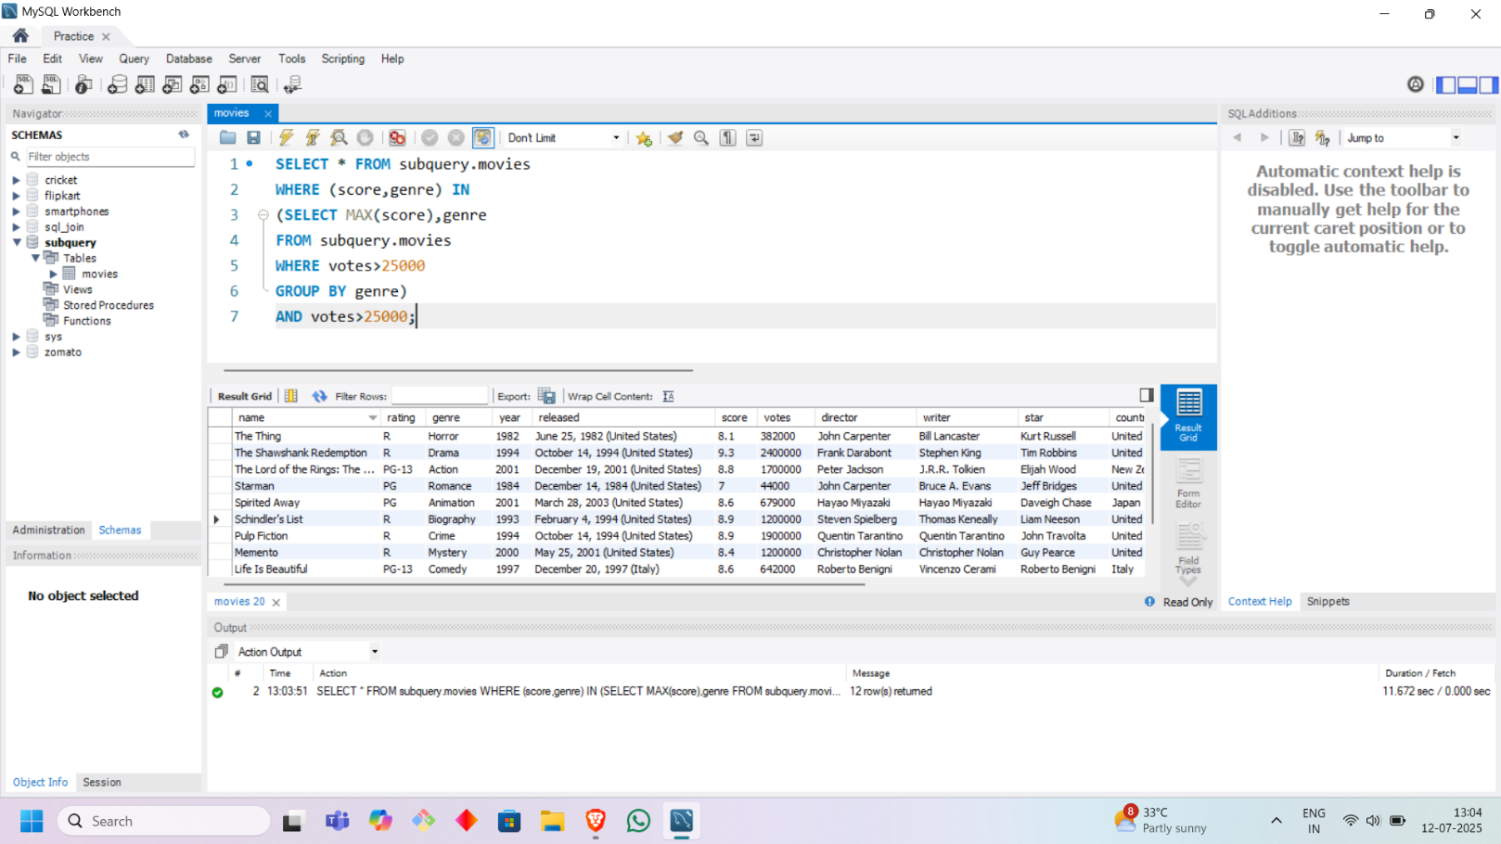

* **Find the highest grossing movies of top 5 actor/director combo in terms of total gross income**

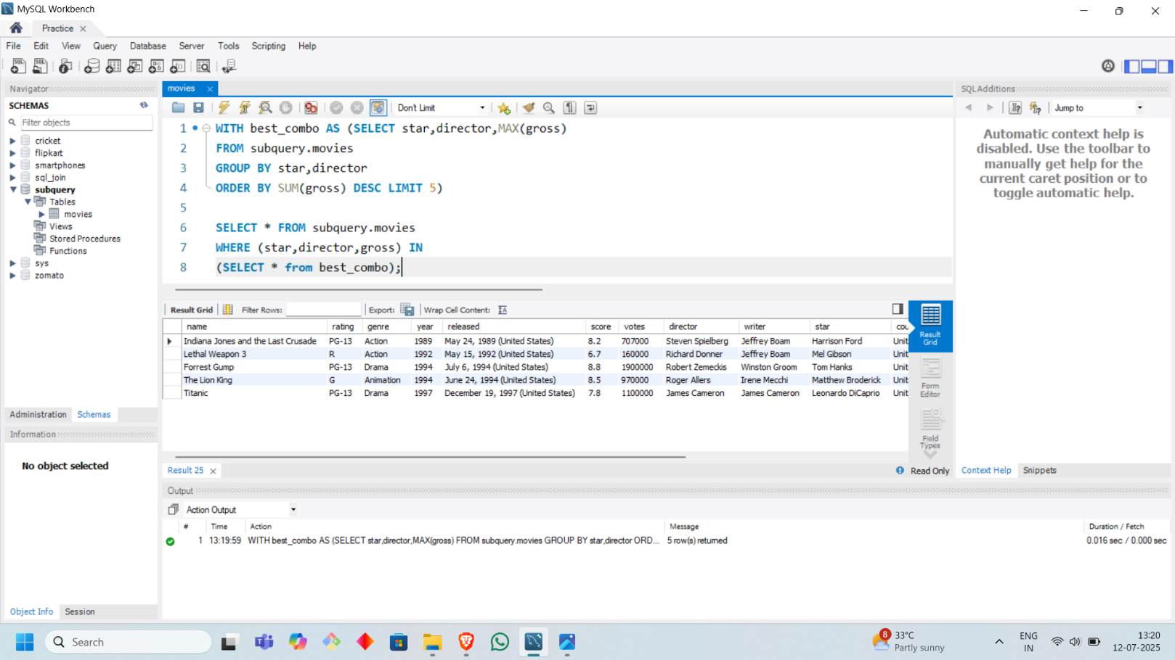

1. **CORRELATED SUBQUERY**

* **Find all the movies that have a rating > average rating of movies in the same genre**

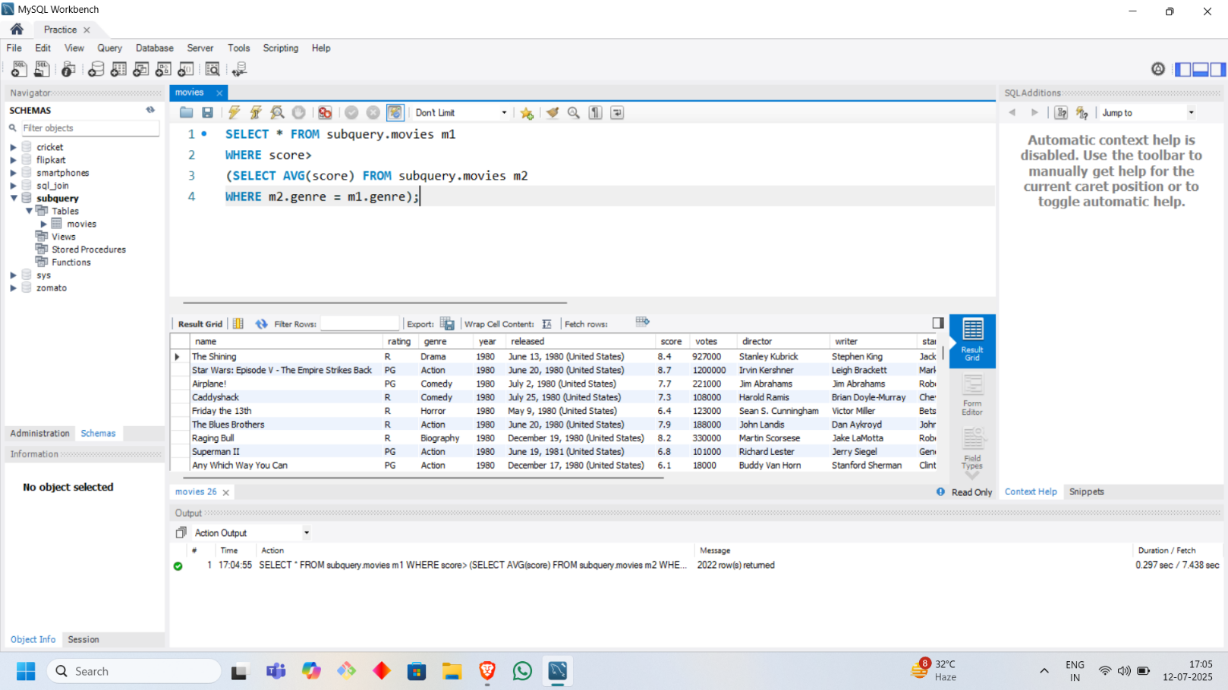

* **Find the favorite food of each customer**

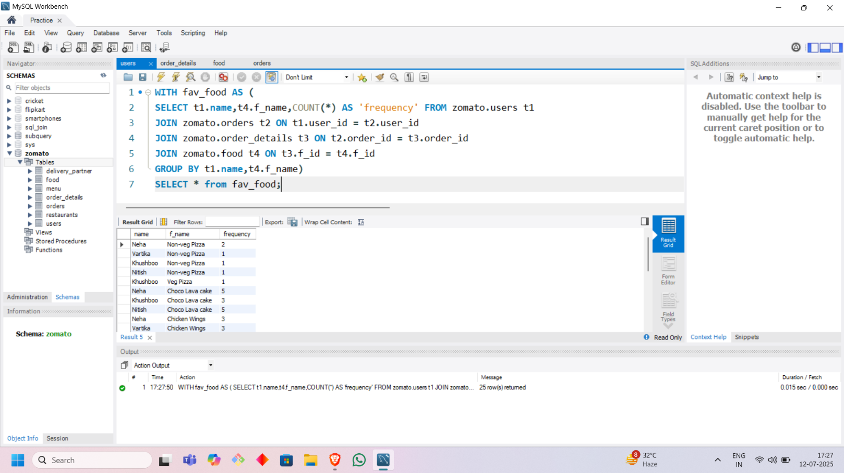

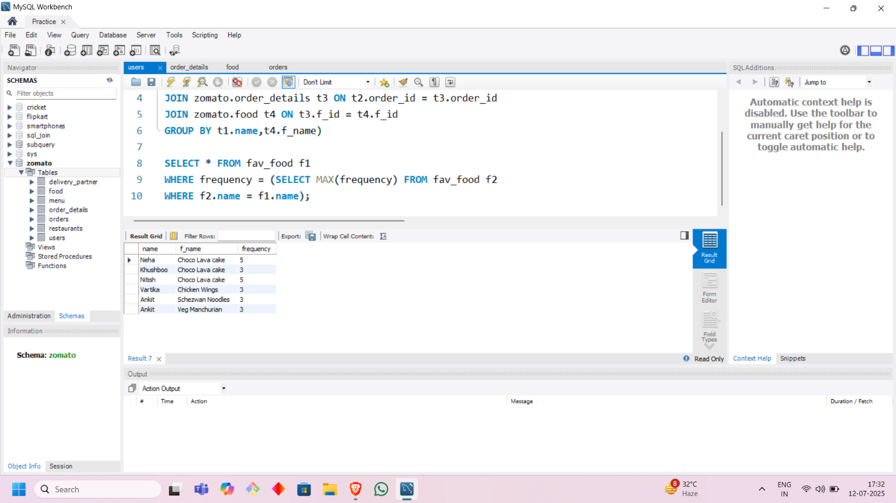

1. **USAGE WITH SELECT**

* **Get the percentage of votes for each movie compared to the total number of votes**

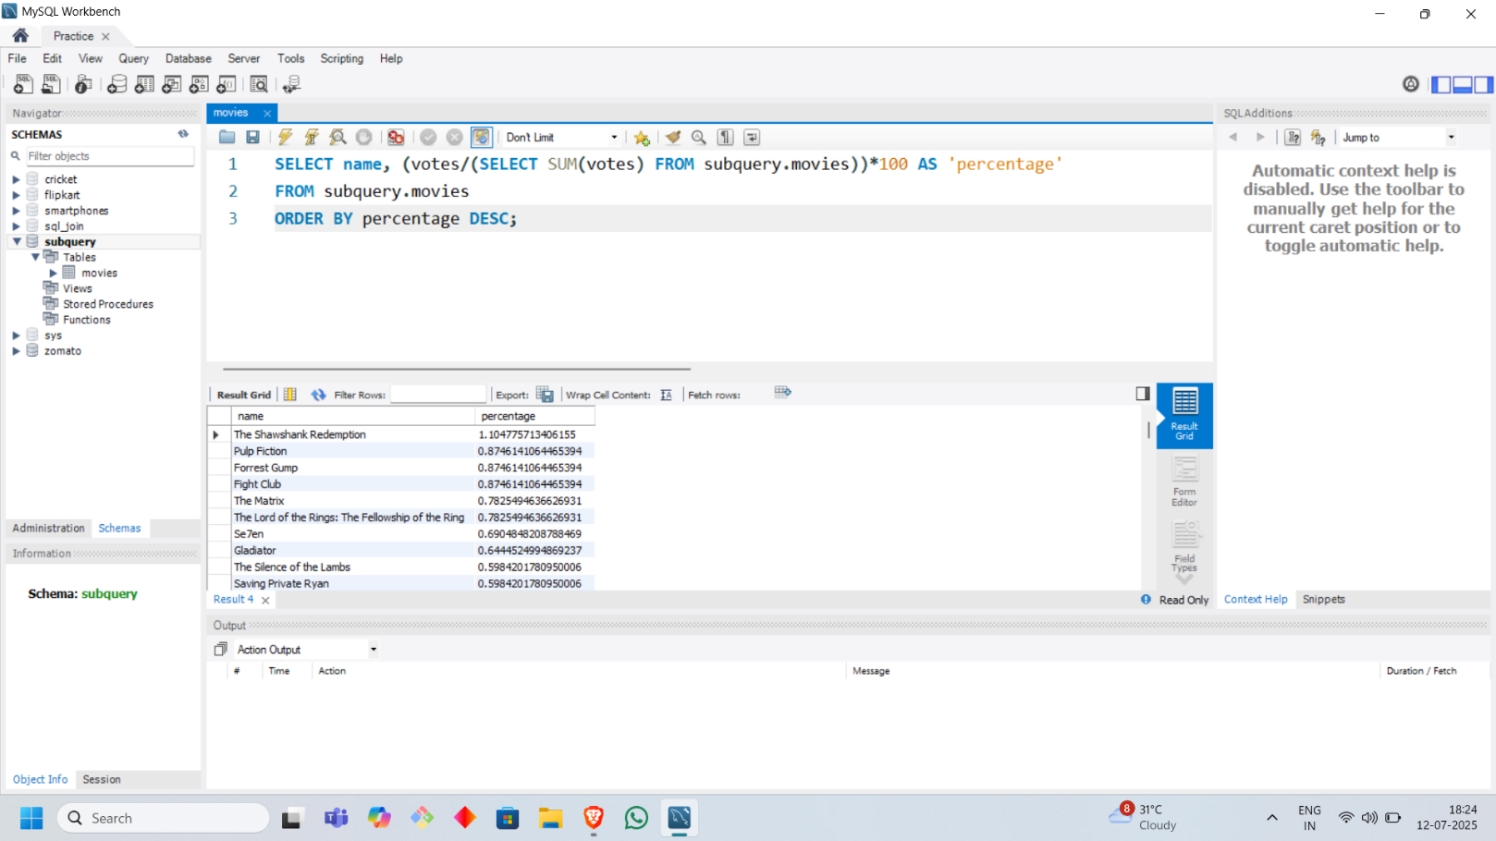

* **Display all movie names, genre, score and avg(score) of genre**

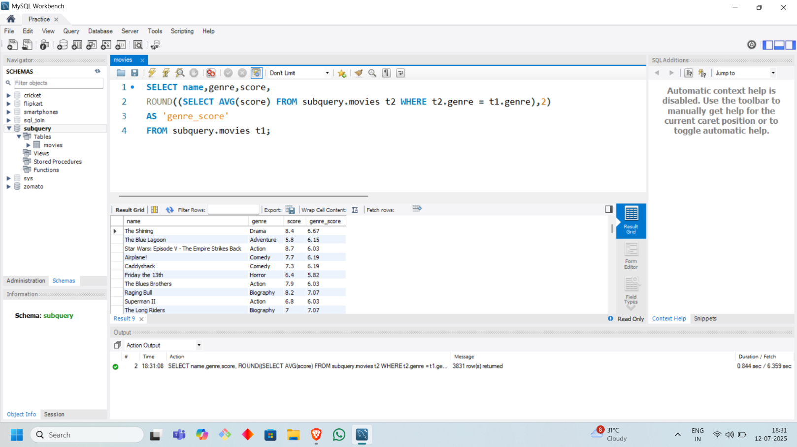

1. **USAGE with FROM**

* **Display average rating of all the restaurants**

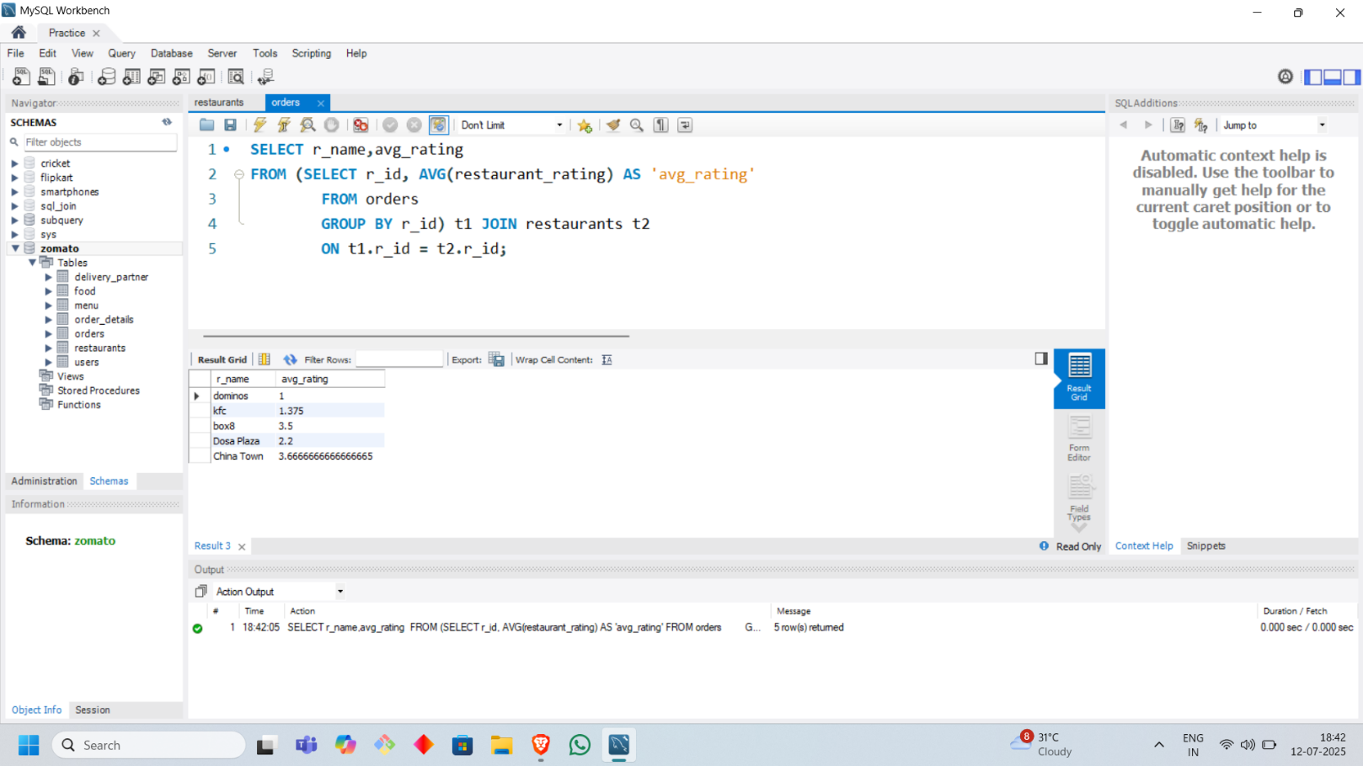

1. **USAGE with HAVING**

* **Find genres having avg score > avg score of all the movies**

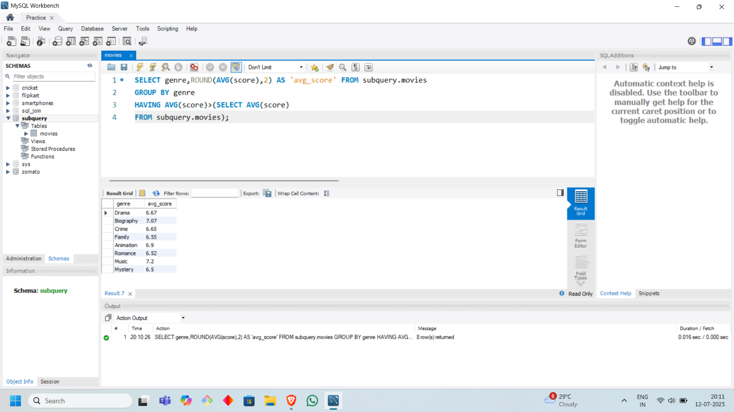

1. **USAGE with INSERT**

* **Populate a table created as loyal_customers with records of only those customers who have ordered food more than 3 times**

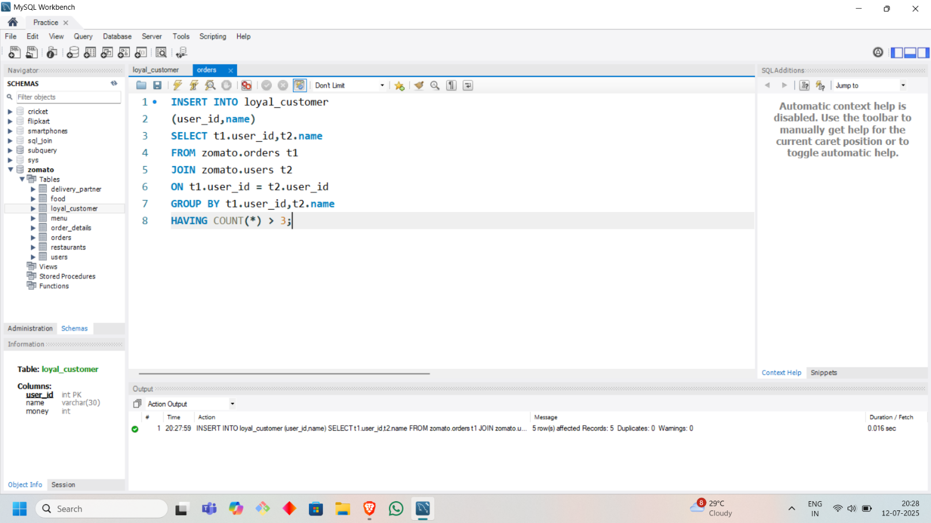

1. **USAGE with UPDATE**

* **Populate the money column of loyal_customers table using the orders table. Provide a 10% app money to all customers based on their order value**

